As this is a course in computational modeling and data science, you will be completing all of your assignments using your computer! However, in order to do so there are a number of things you need to set up before the course starts.

**MAKE SURE TO COMPLETE ALL STEPS LISTED IN THIS DOCUMENT BEFORE YOU START THE ASSIGNMENTS AND BEFORE YOU COME TO CLASS**

Follow the instructions below to get the Anaconda distribution of Python installed on your computer. Even if you already have a version of Python installed on your machine, we encourage you to go through this installation process as the assignments will assume that you are working with the same versions of the Anaconda Python packages that the instructors are using.

1. Go to the Anaconda Download webpage: <https://www.anaconda.com/download/>

2. Select the appropriate operating system (Windows | macOS | Linux) for your computer (it may auto-detect the correct operating system).

3. Download the Python 3.x (64 bit recommended) version.

4. Follow the online documentation to install Python for your specific operating system: <https://docs.anaconda.com/anaconda/install/>

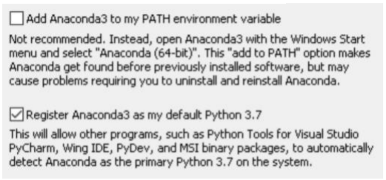

**Make sure you tick both of these boxes: Add to PATH and as default Python 3.xx**

5. Open the command line program on your computer.

On Windows, type CMD in the run box in the Start menu.

On Mac, type “terminal” in the spotlight search and run the “Terminal” application

On Linux, open up the “Console” application

6. Type “jupyter notebook” in the command line and hit enter.

If everything goes correctly, a browser window should open up with the Jupyter interface running. If things don’t work, don’t worry, we will help you get started.